

*So it’s come to that time of year. The end of the university year and the time when everyone ups and leaves the hallowed hall of Bruce. Sadly this means that this is the final Billitin for the year, and so a massive shoutout is due to Harry Main and Jyoti Goonawardena for finding that perfect balance between Bants and News throughout the year, and making the Billitin consistently so entertaining and useful throughout the year!*

.

*Doing it for Bill since 2014*

THE BRUCE BILLITIN

**ISSUE 20: Monday 16th November – Sunday 22nd November**

*Doing it for Bill since 2014*

THE MANY WONDERS OF CANBERRA

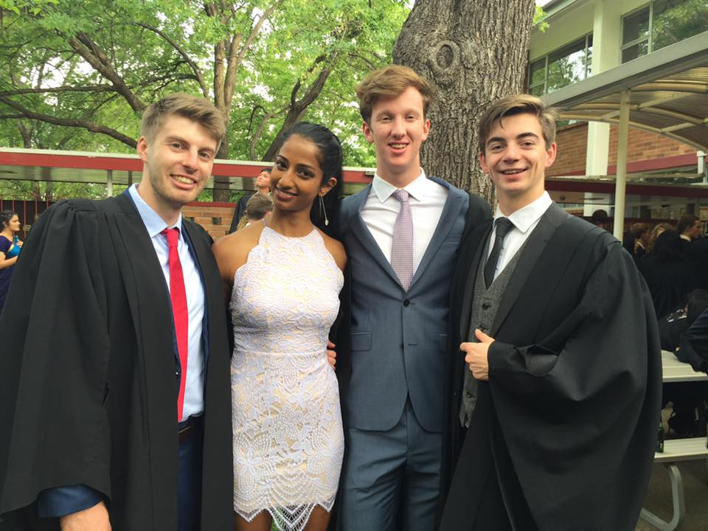

Surprisingly, not much is on in Canberra this week, despite it being our Nation’s Heart and Capital, however the few events which are on are listed below:

* **Until 19th Nov Distant Warriors at the Canberra Glassworks**: A special ANZAC centenary exhibition inspired by the stories of Indigenous Australian and Maori soldiers
* **20th Nov 30th Anniversary of Questacon Science Circus**: FREEEEEEEEEEEEEEEEEEEEEEEE ENTRY to Questacon.
* **21st Nov Voices in the Forest**: An outdoor concert is being held at the National Arboretum this Saturday. Be prepared for a s
* **21st Nov-29th Nov DESIGN Canberra 2015:** A four day festival of craft and design celebrating the culture of Canberra. Go onto designcanberrafestivalcom.au for more details.

From past and present secretaries, we'd just like to say thank you for putting up with this rambling double sided piece of paper we call the Billitin!

SCHIMDT HAPPENS- What’s on in ANU

The ANU is a busy place, even during exams, as obviously he

* PUBLIC LECTURE: Andrew Leigh talks about Robots, remuneration and restructuring at 5:30 pm in University House on the 16th Nov
* TALES FROM A DISEASE DETECTIVE: 17th Nov Associate Professor Sanjaya Senanayake talks about her life diagnosing diseases at 6pm in the Centre on China in the World.

ANUSA are continuing to run their Chillapalooza event up until exams finish.

BRUCE HALL: An interactive Guide

Bruce Hall is a beautiful place. And like all beautiful places, there is plenty to do. Over the next week there will be a few choice activities to take part in, many of which could probably be found with a casual stroll around the boundaries of the college.

* **16th Nov 12 hour Downball challenge:** Get your game on and head down to South Quad for 12 hours of Downball, or alternatively just laugh as Lachie and Sagar both try to hit balls from 8am- 8pm.
* **Chat and chill with Friends**
* **Checkout…..**Ummm yeah.

Really, with very little organised, it’s up to you guys to have a good time and make the most of all Bruce has to offer!



**A message from Bill**

*Of all the things I am not very good at, living in the real world is perhaps the most outstanding-* Bill Bryson



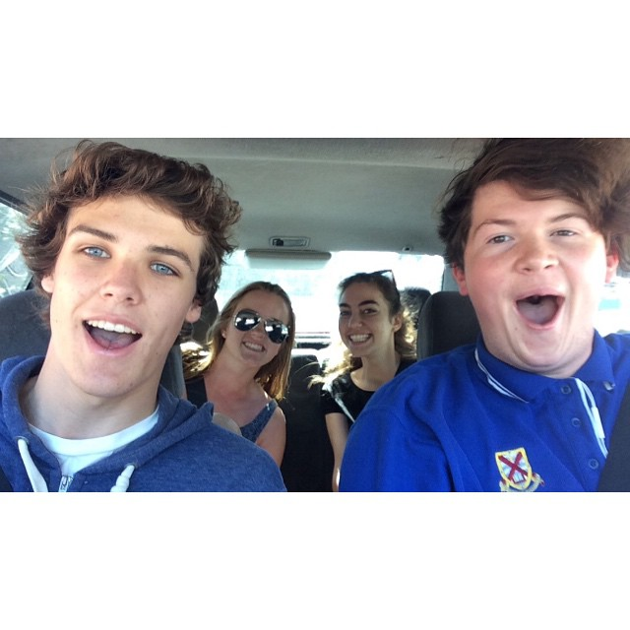

A BEGINNER’S GUIDE TO   
HANDSDOWNSPORTSACTIVEWRISTY

With Lachie ‘Smashews’ Matthews

Handball is a game with a few rules. The first is that it is not called handball.

The second is that there are no rules. Now this may seem like an oxymoron, but

refer to the second rule, which also applies to grammar and logic when playing

this king of games.

Everything happens on the court. A place of great dignity, almost like my

hometown of Yakandandah. Which you should visit by the way. Definitely.

And it’s two pubs. And five cafes. And……send help this summer. You’ll find me buried under a pile of old Yackity yaks behind the pub, one hand disconsolately hitting a ball into the wall.

Firstly, never say ‘It’s only handball.’ No. It’s not. What is wrong with that statement is everything. And you should reassess everything if you believe so. See, downhandsportsball has a long and proud history in the old school yard, one which stretches back centuries. It was said that Jesus himself said It’s only handball, and that this was the tipping point in Pontius Pilate’s decision to stand aside. Secondly, the aim is to hit the ball firstly into your court, and then into someone else’s. It’s as simple and as complex as that. The nuances are infinite. In fact, there are so many that I think I need to have a lie down…

But first, I will introduce you to some of the BNOHD’s you may encounter on the Court. See you out there!

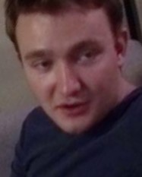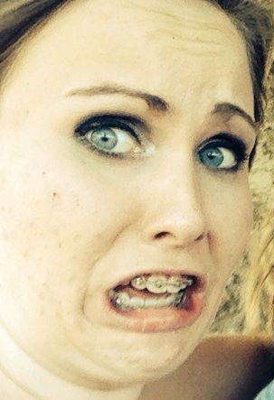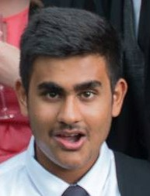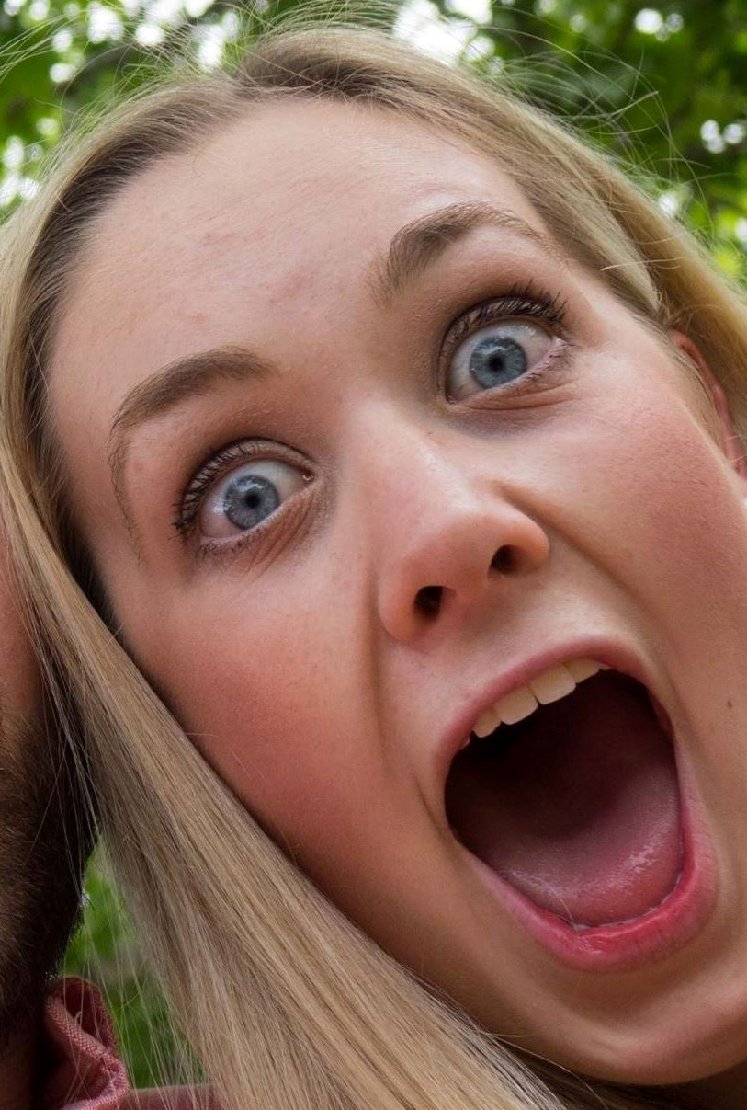

So that’s all from the Billitin for this year, have an awesome summer, enjoy the good weather, and try to survive it despite the lack of bants and info on what is going on in Canberra and Bruce Hall, the place that we have all come to call home.

Billitin out!



**Cameron 'Hash Browns' Morris**Signature Move:  
The Free Kick  
Catchphrase:  
‘Collusion hurts everyone’

**Ashlea 'All work no play' Cameron**Signature Move:  
The low blow  
Catchphrase:  
‘I WILL HATE YOU FOR ETERNITY’

**Tushar 'the punisher' Khandelwal**Signature Move  
The cross court kill shot  
Catchphrase  
‘It was lines I swear’

**Jacqueline 'Activewear Boardies' Lange**Signature Move  
Joining the line  
Catchphrase:  
‘Not again’

**Glen 'The King' Cocheril Lopez**Signature Move:  
The Spin and you’re Gone  
Catchphrase:  
‘I’m a merciful King’

1. Niccolo Machiavelli 2. Ned Kelly 3. Switzerland in 2007 during a training exercise, 4. 1967

5. Terry Pratchett, 6. Cubism, 7. 4, 8. 1946, 9. In Flander’s Fields

TRIVIA

1. Who wrote the seminal political novel, ‘The Prince’? 6. What is the name of the art movement co-founded by Picasso?

2. Which Outlaw supposedly said ‘such is life’ before being executed? 7. How many times have the Socceroos been to the World Cup?

3. Which country accidentally invaded Lichtenstein? 8. When was Donald Trump born?

4. What year were Pringles first sold? 9. What is the name of the poem which inspired people to wear

5. Which author is referenced throughout the code of poppies on Remembrance Day?  
 Dragonlair? 10.

A FINAL NOTE